Scope: To configure and enable SNMPv2 public monitoring using the free tool provided by ManageEngine (installed on Windows platform), and DSSV6
How to configure DSSV6 SNMP and the ManageEngine MibBrowser Free Tool
Log in to your DSSV6 appliance and navigate to the SETUP→administrator section.
Scroll down to the SNMP settings area, and check the box for ‘Use SNMP’. This will expand the menu and allowing you to configure access over the SNMP protocol in versions 2 or 3.
With SNMP enabled, you receive a wealth of information (CPU usage, system load, memory info, Ethernet traffic, running processes).
SNMP, version 2 does not have encrypted transmission, and authentication is done only via the community string.
SNMP, version 3 has an encrypted transmission feature as well as authentication by username and password.
In this example, SNMP V2 is being used.
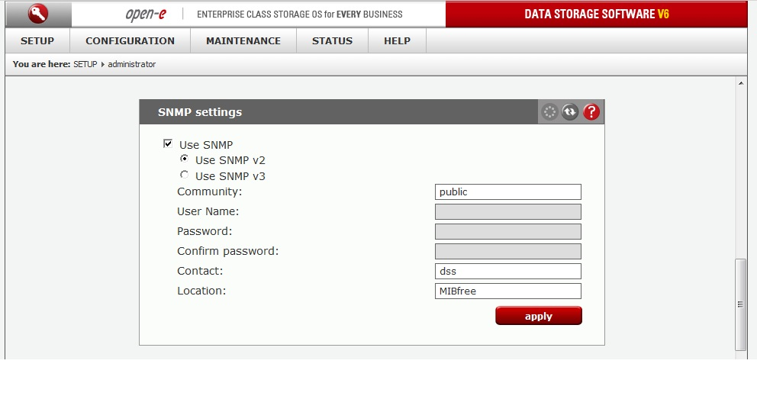
The community string you set can contain up to 20 characters, while the password (version3) needs to have at least 8 characters.
System location and system contact are only for your information. For example, when you connect from an SNMP client, you will see your location and name.

Start MIB Browser. The default set of modules installed will work.
In the left folder browser, expand the SNMPv2-MIB module and select snmpV2.
Enter your DSSV6 settings on the right side:
Host: <<your DSSV6 default active IP>>
Community: <<same as entered in DSSV6 SNMP settings.
Port: 161 (this is the default)
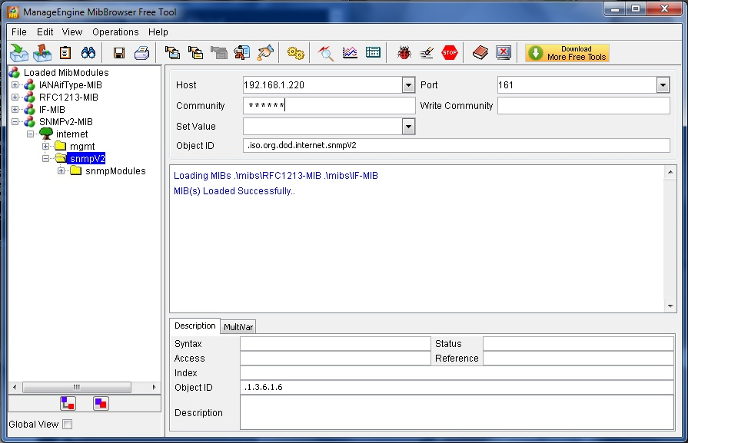

From the EDIT menu in MIB Browser, select Settings. This will open the settings dialog box.
The default protocol in MIB Browser is v1, change this to v2c, and click OK to confirm the change.
NOTE: Settings will need to be done each time MIB Browser started.
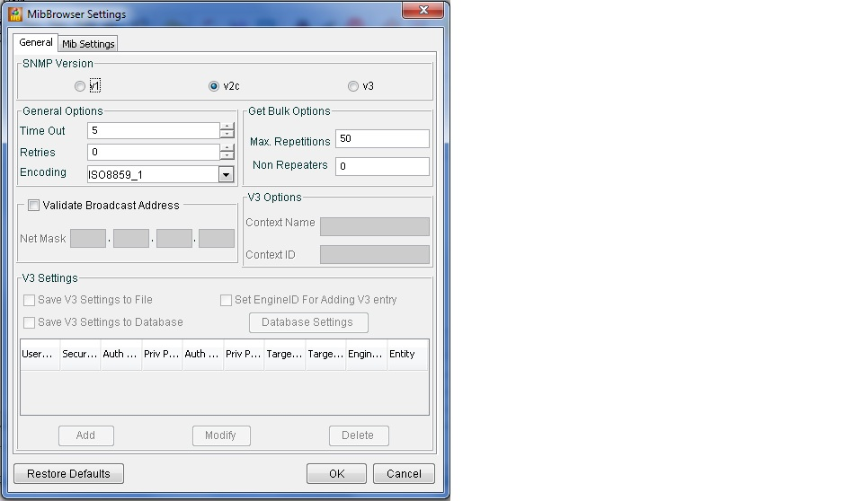

From the Operations Menu, choose GET, and MIB Browser will retrieve variables and values from the DSSV6 server.

